|  |
| --- |
| Use Microsoft Identity Manager to set-up User Profile Sync in an upgraded SharePoint Server 2016 farm (using sync configuration from the previous SharePoint version) |
|  |

**Summary:** Microsoft Identity Manager, MIM, is new to SharePoint Server 2016, replacing FIM. This article tells you how to convert FIM sync XML files to MIM sync config files for use in configuring your new MIM server.

**Applies to:** SharePoint Server 2016 | Microsoft Identity Manager 2016

**Published:** Sept 2015

**Contents**

* Converting an Exported sync configuration
* Convert the XML files
* Import the converted files
* Start your Agents
* More resources

**Note**:

The solutions files referenced in this article are available for download [here](https://github.com/PnP/tree/master/Solutions/UserProfile.MIMSync.). See the section ‘Download the solutions files that you need’ for more details.

**Converting an Exported sync configuration**

If you have an existing SharePoint Server 2013 farm that uses Forefront Identity Manager (FIM) for profile import, you may want to save some time by converting the synchronization configuration from that server farm for import to your new Microsoft Identity manager (MIM) solution. FIM sync server configuration can be exported into an XML file that can be converted into MIM sync service configuration files. There are two steps involved.

* Convert the Sync service XML files.
* Import the Sync service XML files using the MIM sync service manager.

The sync service config files will not change dramatically between FIM and MIM and should work in MIM 2016 post conversion. Also, customizations to your sync configuration should be preserved by the conversion. The goal of conversion is to replace the SharePoint management agent with the newer SharePoint User Profile Store Connector.

|  |
| --- |
| **Important:** |
| Your FIM-based synchronization files are required for the conversion process. These files can be found on the SharePoint server that hosts the User Profile Application where sync is enabled. Make sure to export your FIM synchronization files and back them up in a safe location.   1. On the SharePoint server that hosts your User Profile application and sync, open the synchronization service manager for FIM (the Miisclient.exe), from *C:\Program Files\Microsoft Office Servers\15.0\Synchronization Service\UIShell\miisclient.exe*. 2. Click **File** and then **Export Server Configuration**. If prompted, enter the credentials for the FIM sync service. 3. You may see a warning telling you that management agents should not be run and changes shouldn't be made during export. Click **OK**. 4. Use **Browse for folder** and find a good location to back-up your synch configuration, click to **Make new folder** and append the date to the export folder (so that you know how recent/out-of-date your configuration is the next time you check). Click **OK** to export.   The XML documents that you need for the conversion process will be placed in this folder so be sure the location is secure and stable. |

**Convert the XML files**

Convert the FIM sync service configuration to a MIM sync service configuration, you need to run the ConvertTo-SharePointEcma2 command as shown below. In our example, the path to the original FIM files sits on the C drive in a folder called *Sept2015FimSyncConfigurationFiles*, you will need to update the -Path for your environment.

|  |  |
| --- | --- |
| **XML** | **Copy code** |
| ### Load the SharePoint Sync Module  Import-Module C:\SharePointSync\SharePointSync.psm1 -Force  ### STEP 1  ### Convert the FIM Sync Configuration Files to MIM Sync Configuration Files  ConvertTo-SharePointEcma2 -Path C:\Sept2015FimSyncConfigurationFiles -Verbose  ### STEP 2  ### Use the Synchronization Service manager to import the XML files  ### The command below just opens the Synchronization Service manager  ### The configuration must still be imported (File > Import Server Configuration)  Start-SynchronizationServiceManager | |

|  |
| --- |
| **Tip:** |
| Curious? The 'Ecma2' in the ConvertTo-SharePointEcma2 command stands for Extensible Connectivity Management Agent, second version. |

**Import the converted files**

The converted files can now be moved to the MIM server or servers and imported into an instance of the MIM Synchronization Service Manager (Miisclient.exe).

1. To find the Synchronization Service Manager (Miisclient.exe) on your MIM server, use the Windows Key and search for 'Synchronization'.
2. Click **File** in the menu, and then **Import Server Configuration**.

The sync service manager will read the XML files and prompt for connection details for each management agent included in the configuration. Most likely only passwords will be required, because the details of the connection are saved in the configuration, but passwords *are not*. Be sure to have your passwords ready (and secured).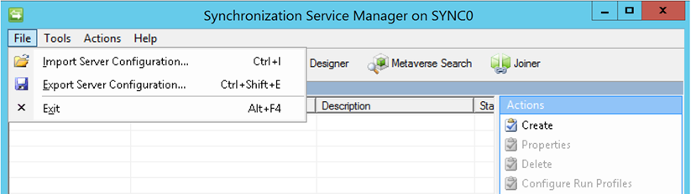

|  |
| --- |
| **Tip:** |
| The Synchronization Service will try to connect to each of the systems, so make sure the connection details are right and the systems are up and accessible. If any errors occur during reading the XML file, check the Application event log. |

**Start your Agents**

When the import completes you're ready to start your management agents and synchronize. Remember that each separate management agent needs to import and then sync all its objects. Also, Exports should be made after the sync completes so that your management agent is in a converged state at the end of this process. Please be aware this final step can take some time. Consult your SharePoint Farm Administrator to get estimates of import and sync durations and be sure plan accordingly.

**More resources**

For more information, see the following resources:

* Do you need and overview of SharePoint Server 2016's switch of FIM to MIM (including all the prerequisites)? Please see [User Profiles in SharePoint Server 2016](http://84972766-6527-4791-ae68-02d3a50b67f0)
* Are you about to set up a brand new deployment of Microsoft Identity Manager for use with SharePoint Server 2016? See [Deploy a new Microsoft Identity Management (MIM) server for User Profiles in SharePoint 2016](http://b4c2dace-97fc-43c7-8991-44279a4fe05d)
* See [this link](http://4d94f491-4f01-4ab8-8c4b-f086c2ccfb89) for more detail on Profile Synchronization in SharePoint Server 2013.
* If you have questions about identity management, click [this link](http://e01cfb34-60d3-42c7-91f8-f7436a25c149) for a technical reference on the SharePoint Connector for FIM 2010 R2 (the FIM version embedded in SharePoint Server 2015).